2024 MALAWI PROVINCIAL CHAPTER
FIRST SESSION (22-24 TH FEBRUARY 2024)

DAY THREE REPORT (24 TH FEBRUARY)
The third day of the chapter started with a Morning Prayer service at 07:00 AM, which was prepared by Bethel community the provincial house. The theme of the prayer service was “Transformation and growth of Malawi province in the spirit of our founders” which is also the main theme of our provincial chapter. The prayer service dwelt on a reading from our constitution article number 55 “God in our life”.
The first session of the day started at 08:30 AM with Chapter prayer led by Br. George Muliya. Discussions during this session in the morning hours centered on some issues, firstly was the issue of FIC journey to spiritual enrichment. One member of the council explained the importance of the spiritual journey in the congregation. Those people involved in recent spiritual journey were asked to share more about the spiritual enrichment. Members who participated expressed their gratitude for participating in this spiritual journey. They agreed that the exercise was fruitful and beneficial for the spiritual growth of an individual as well as congregation. Secondly, there was an issue of communication in the province and outside world. The provincial council expressed their gratitude to Bro. Gasper for paying more attention when it comes to the issue of communication in the province as well as outside our province. He asked community members to improve on communication at community level.
The afternoon session, focused on Election of General chapter delegates. Before the election, members were asked to go into small groups to discuss the qualities of a delegate member. The groups came up with different qualities that each member to be elected should portrays. Then after this exercise members were asked to vote using secret ballot. After the process of voting the following Brothers were elected to be our delegates of general chapter, namely Bro. Trustful Mwachande and Bro. Lawrence Nkode. Finally the chapter delegate elected Bro. Mike Mbato as substitute.
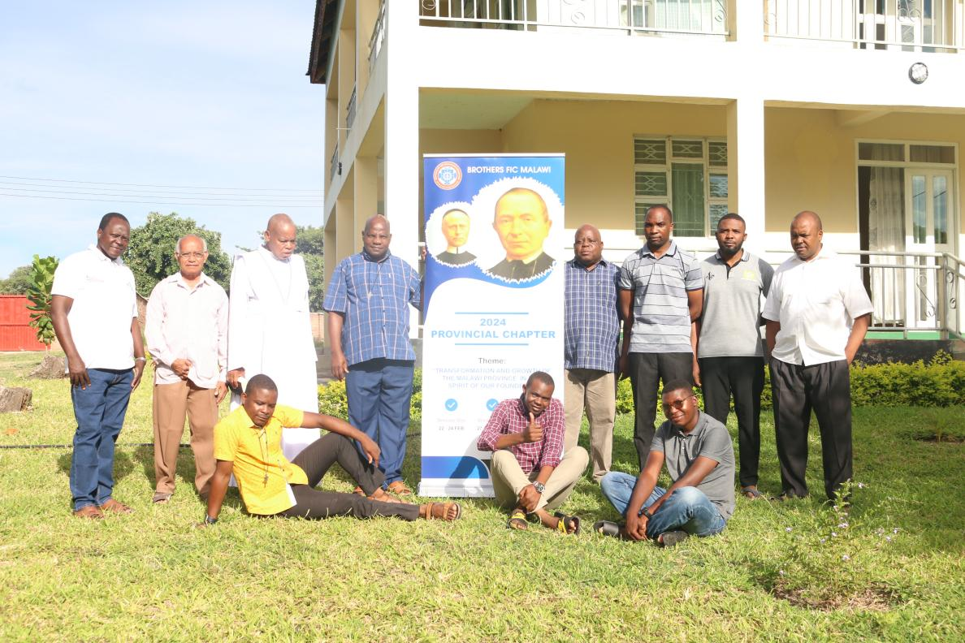
A group photo of 2024 Malawi Provincial Chapter delegates.
The day was concluded with a Eucharistic Mass around six o’clock in the evening. During the homily, more emphasis was made on transfiguration of Jesus. The celebrant said this is in line with the theme of the chapter of transformation and growth in the Province.

Reported by: Bro. Mike Mbato, FIC

