FIC GHANA PROVINCE IS FIFTY YEARS
The celebration of the FIC Brothers golden jubilee in the Ghana Province was preceded by the inauguration of a sixteen classroom block with toilet facilities in Nandom in the upper west region of Ghana. The occasion was attended by people of all walks of life including politicians, traditional leaders, chiefs and civil servants. The Provincial Superior (Bro. Seregious Dery) in his welcome address indicated that the significance of the occasion lies in the provision of a visible sign of the FIC Brothers apostolic presence in Ghana since 1965. As a teaching congregation he said, a cursory look at our past, present and future direction, leaves us with the feeling that although our apostolic concentration over the past fifty (50) years has largely been to improve access to quality and affordable education to the less privileged in society, we think that this vision and mission is not yet fully accomplished. This is because there are still many settlements in some rural areas and even in some towns where access to good basic education still remains a challenge. Bro. Seregious stated that the essence of the FIC Jubilee School is not meant for profit making but to:
- Improve access to quality education that is underpinned by sound moral and Christian values and the integral development of the beneficiary community. Thus pupils who pass through this school should be disciplined; feel adequately empowered for life and should develop the spirit of service to humanity wherever they find themselves.
- Reduce school dropout rate particularly the female child in the locality
- Increase pupils’ success rate at the Basic Education Certificate Examination (BECE)
- Make the locality also attractive to some caliber of government employees’ e. g. doctors, nurses, teachers’ Agricultural workers and people with special expertise who would otherwise not accept posting to this area because of lack of quality schools for their children.
The Provincial Superior reassured the head teacher and the workers of the school that the Provincial Council will continue to support the school for the first two years of its start to ensure a smooth take off and accelerated development. The Rector of Nandom Basilica who preached the sermon was full of praises to the FIC congregation, Ghana Province for the wonderful performance in the education sector despite the challenges due to reduction in their numbers as a result of death, dwindling vocations and members exiting the congregation. Solidarity messages/speeches were delivered by the Regional Manager of Catholic Schools, the Paramount Chief of Nandom Traditional Area; the District Director of Education, Nandom District and the District Chief Executive, Nandom District. Development partners of the Brothers FIC-Ghana Province, Rotary Club International from The Netherlands and Germany graced the occasion and donated items comprising story books, rag sacks and cupboards. The initial enrolment of the school is forty seven (47) comprising primary one, two and four. Every pupil was given a rag sack to be used as receptacle for borrowed books. They also gave special award to Bros. Albert Ketelaars and Bosco Bongnia for their hard work and dedication to the work of bring homes to the homeless and serving the poor. Bro. Peter Saatuo received the award on behalf of Bro. John Bosco Bongnea for he was not well to attend the occasion.
The sod cutting ceremony to officially inaugurate the school was performed by the Vice General Superior of the Brothers FIC, Bro. Guido Sukarma.

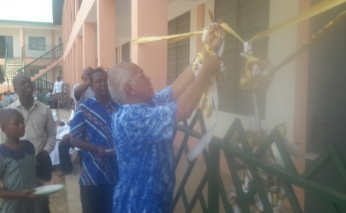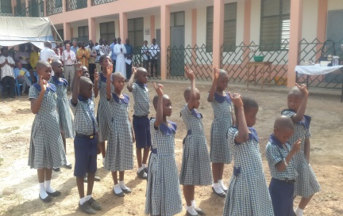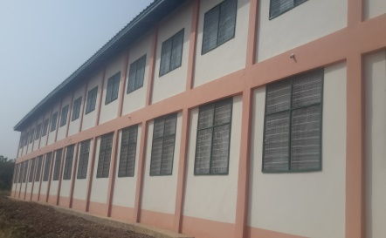
Sod cutting ceremony By Bro. welcome by school pupils back view of the FIC Jubilee sch
Guido Sukarma
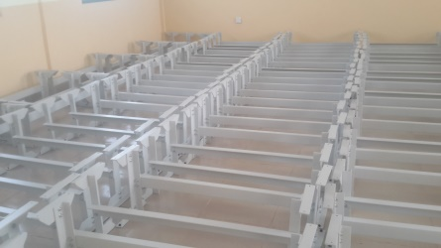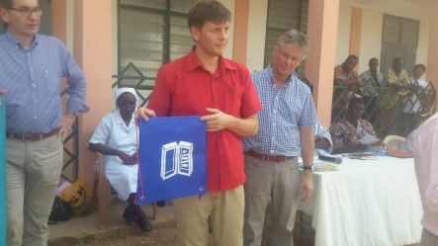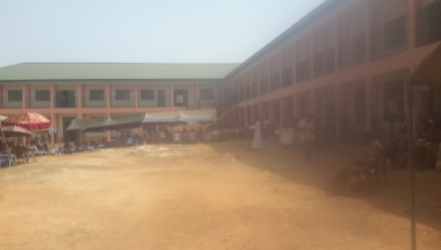
Furniture jointly donated by rotary presentation of bags by Rotary Front view of the Jubilee school
club Of Germany and Netherlands club members
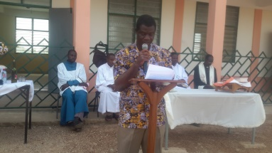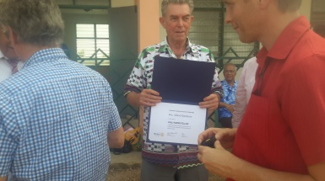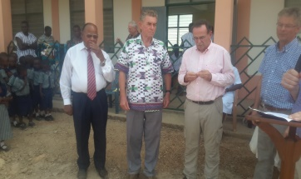
Provincial Superior delivering Bro. Albert receiving award Bros. Peter & Albert posed to receive awards
His welcome address

